Batch: A1 Roll No.: 16010123012

Experiment / Assignment / Tutorial No.: 04

Grade: AA / AB / BB / BC / CC / CD /DD

Signature of the Staff In-charge with date

Title: Implementation and Analysis of Different Types of CAPTCHA Mechanisms
______________________________________________________________________Objective: To study and implement different types of CAPTCHA systems to understand how they prevent automated bot access.
______________________________________________________________________
Expected Outcome of Experiment:
Course Outcome | After successful completion of the course students should be able to
 | Students will be able to explain the working of CAPTCHAs and implement basic text, audio, mathematical, and image-based CAPTCHA techniques.
______________________________________________________________________
Abstract:
CAPTCHA (Completely Automated Public Turing Test to Tell Computers and Humans Apart) is a security mechanism used in web applications to distinguish human users from automated bots. It prevents misuse such as spam submissions, brute-force attacks, fake registrations, and data scraping by introducing a challenge–response test that is easy for humans but difficult for automated programs. In this experiment, different types of CAPTCHAs including text-based, audio-based, mathematical puzzles, and image-based object recognition are studied and implemented. The activity helps in understanding their working principles, security significance, and practical usability in protecting web systems.
Related Theory: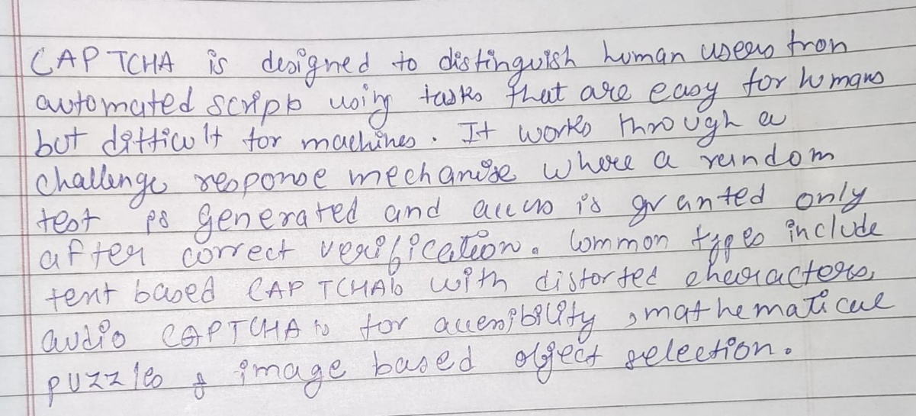
Implementation Details:
import random
import string
from PIL import Image, ImageDraw, ImageFont
from IPython.display import display, Audio
import time
from gtts import gTTS
import os

def generate_text_captcha():
captcha_string = ''.join(random.choices(string.ascii_uppercase + string.digits, k=6))
print("\n=== TEXT CAPTCHA ===")
print("CAPTCHA:", captcha_string)
user_response = input("Enter the CAPTCHA: ")
if user_response.strip().upper() == captcha_string:
print("Verification successful!\n")
else:
print("Verification failed!\n")

def generate_math_captcha():
number_one = random.randint(1, 10)
number_two = random.randint(1, 10)
print("\n=== MATH CAPTCHA ===")
print(f"Solve this: {number_one} + {number_two} = ?")
try:
answer_input = int(input("Your answer: "))
if answer_input == number_one + number_two:
print("Verification successful!\n")
else:
print("Incorrect answer. Verification failed!\n")
except ValueError:
print("Please enter a valid number.\n")

def generate_image_captcha():
captcha_content = ''.join(random.choices(string.ascii_uppercase + string.digits, k=5))
image_canvas = Image.new('RGB', (180, 70), color=(255, 255, 255))
image_drawer = ImageDraw.Draw(image_canvas)
try:
font_style = ImageFont.truetype("arial.ttf", 36)
except:
font_style = ImageFont.load_default()

image_drawer.text((20, 15), captcha_content, fill=(0, 0, 0), font=font_style)

for _ in range(8):
x_start, y_start = random.randint(0, 180), random.randint(0, 70)
x_end, y_end = random.randint(0, 180), random.randint(0, 70)
image_drawer.line(((x_start, y_start), (x_end, y_end)), fill=(0, 0, 0), width=1)

print("\n=== IMAGE CAPTCHA ===")
display(image_canvas)

time.sleep(1)
user_response = input("Enter the CAPTCHA text shown above: ")

if user_response.strip().upper() == captcha_content:
print("Verification successful!\n")
else:
print("Verification failed! The correct answer was:", captcha_content, "\n")

def generate_audio_captcha():
captcha_audio_text = ''.join(random.choices(string.ascii_uppercase + string.digits, k=5))
audio_file_path = "captcha_audio.mp3"

print("\n=== AUDIO CAPTCHA ===")
print("Listen carefully...")

tts = gTTS(text='Please enter the following code: ' + ' '.join(captcha_audio_text), lang='en')
tts.save(audio_file_path)

display(Audio(audio_file_path, autoplay=True))
time.sleep(2) # Give some time for audio to play

user_response = input("Enter the CAPTCHA you heard: ")

if os.path.exists(audio_file_path):
os.remove(audio_file_path)

if user_response.strip().upper() == captcha_audio_text:
print("Verification successful!\n")
else:
print("Verification failed! The correct answer was:", captcha_audio_text, "\n")

def run_captcha_system():
while True:
print("CAPTCHA")
print("1. Text-based CAPTCHA")
print("2. Math-based CAPTCHA")
print("3. Image-based CAPTCHA")
print("4. Audio-based CAPTCHA")
print("5. Exit")

user_selection = input("Enter your choice (1-5): ")

if user_selection == '1':
generate_text_captcha()
elif user_selection == '2':
generate_math_captcha()
elif user_selection == '3':
generate_image_captcha()
elif user_selection == '4':
generate_audio_captcha()
elif user_selection == '5':
print("Exiting program. Goodbye!")
break
else:
print("Invalid choice. Please enter 1–5.\n")

run_captcha_system()
Results/Output:
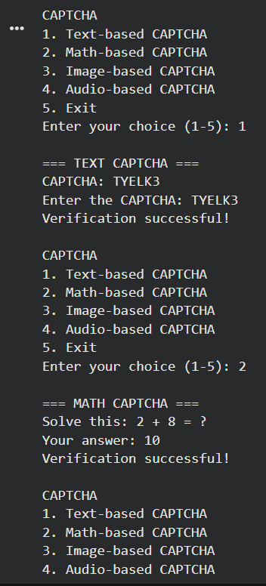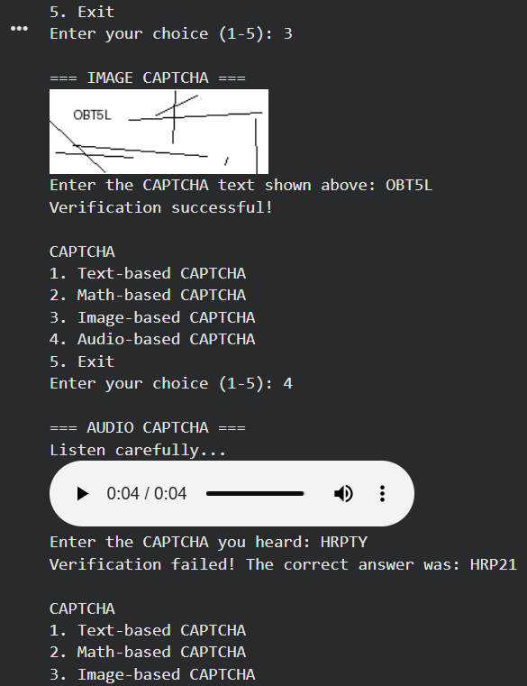

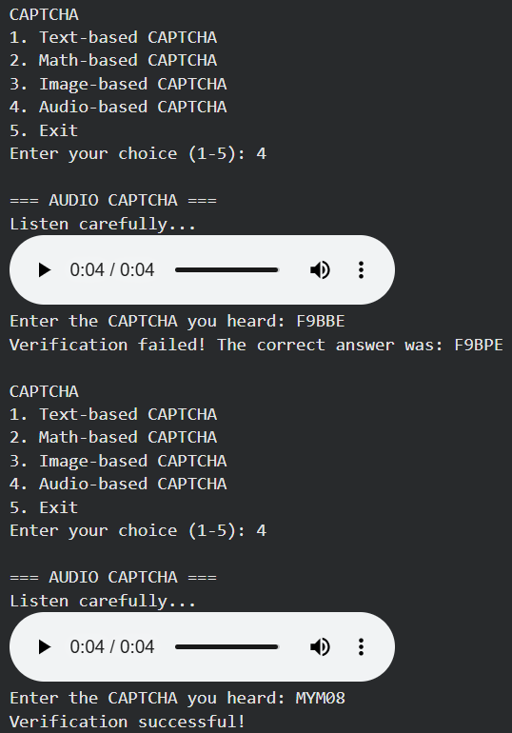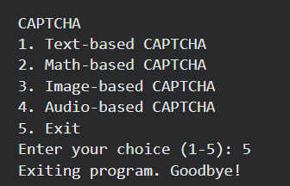
Conclusion:
In this experiment, different types of CAPTCHA mechanisms including text-based, mathematical, image-based, and audio-based CAPTCHAs were implemented and analyzed. The practical execution demonstrated how challenge response tests help distinguish human users from automated bots and prevent misuse such as spam, brute-force attacks, and fake registrations. The activity improved understanding of CAPTCHA design, usability, and its role as an important security measure in protecting web applications from automated threats.
Post-Lab Questions:
- What security problem does CAPTCHA primarily address?
CAPTCHA primarily prevents automated bot access to web services. It protects systems from spam submissions, brute-force attacks, fake account creation, and data scraping by ensuring that the user is human.
- Why is CAPTCHA considered a preventive security control?
CAPTCHA is preventive because it stops malicious automated actions before they occur. By blocking bots at the entry point, it reduces the likelihood of unauthorized or abusive activity.
- What happens if CAPTCHA validation fails repeatedly?
Repeated failures may trigger security actions such as temporary blocking, rate limiting, additional verification steps, or account lockout to prevent automated attacks.
- Where is CAPTCHA typically implemented in a web application?
CAPTCHA is commonly used on login pages, registration forms, password reset pages, comment sections, online polls, and payment forms to prevent automated misuse.
- What role does randomness play in CAPTCHA generation?
Randomness ensures that each CAPTCHA challenge is unique and unpredictable, making it difficult for automated programs to guess or reuse previous solutions.
- Why should CAPTCHA validation be done on the server side?
Randomness ensures that each CAPTCHA challenge is unique and unpredictable, making it difficult for automated programs to guess or reuse previous solutions.

